25-creating Array objects
Start of Arrays and objects https://www.udemy.com/course/modern-javascript-from-the-beginning/learn/lecture/37191250#overview
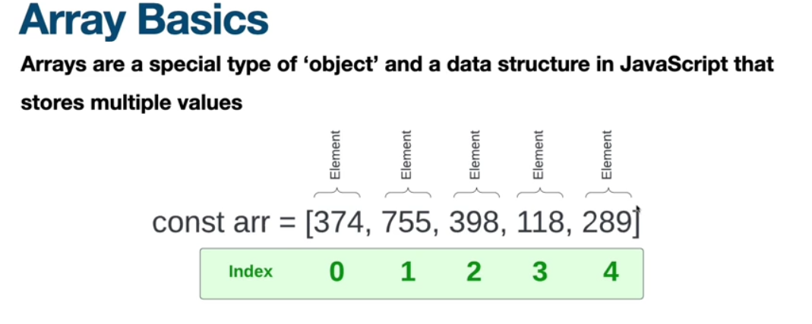
Using array constructor to make an array is less common 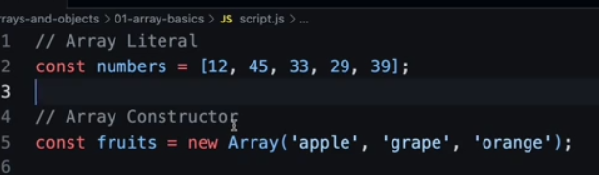
26 Basic array Methods
https://www.udemy.com/course/modern-javascript-from-the-beginning/learn/lecture/37191272#overview
push() - Push a value on to the end of the array
pop() - Take the last value off
unshift() - Add a value to the beginning of the array
shift() - Remove first value
reverse() - Reverse an array
includes() - Check to see if something is in the array - returns true or false
indexOf() - Return the index of the first match to the value passed in

toString(); Return array as a string
join();
slice() returns selected elements in an array, as a new array. Slice takes in the index of the first element and the index of the last element to be included in the new array. The original array remains intact
splice() works like slice() except it takes the index of the first element and the number of elements after the one at the provided index, to remove as a second argument. it also mutates the original array where slice() does not
splice()
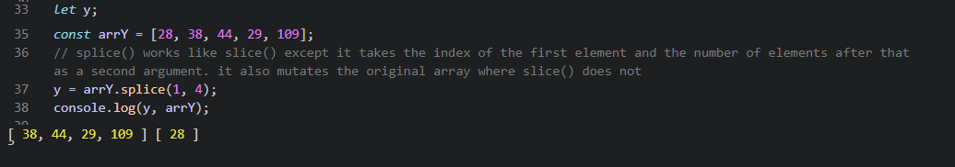
27 Nesting, Concat and Spread Operator
An array can be nested as an index to another array
concat() - Concatenate arrays take items from one array and adding into different array, not nested in another array all at same level
spread operator (...) - Concatenate all contents in one array with all contents of another array x = [...fruits, ...berries];
flat() - Flatten an array - takes the stuff out of nested and makes it all one level
Methods on array object Array.
Array.isArray() Check is is an array
from() - Create an array from an array like value
of() - Create an array from a set of values
29 Object Literals
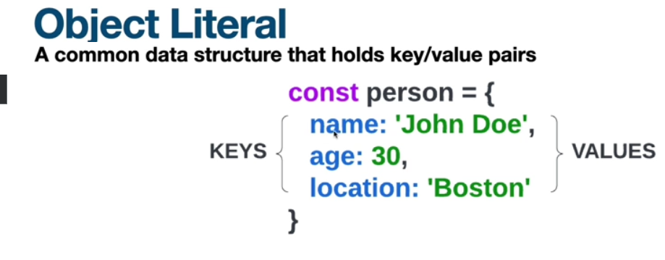
Can access using dot notation or brackets
x = person.name; // Dot notation
x = person["age"]; // Bracket notation
30 Spread Operator Methods -
Object.keys() Get array of object keys
Object.keys().length Get length of an object
Object.values() Get array of object values
Object.entries() Get array of object key/value pairs
hasOwnProperty() Check if object has a property
31 – Destructuring and Naming
32 JSON object -
json is human readable
similar syntax to object literals except the key and value have quotes around them
JSON.stringify() -Return a JSON string corresponding to the specified value, optionally including only certain properties or replacing property values in a user-defined manner.
JSON.parse() -Parse a piece of string text as JSON, optionally transforming the produced value and its properties, and return the value.

